Title Scammondon

- Eight Circular
- Start Point: Rippondon Bowling Club
- Grid Reference SE039198
- Map: Explorer OL 2

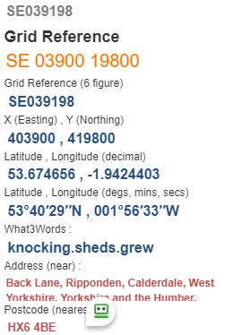
- Go back to road B6113 turn right, take F/P on right and follow up hill to pass thro' houses to road, turn left 50yds approx. turn right and follow road ahead. Take left fork, pass houses then near POWER Lines take track uphill and pass thro' gate @ GR 041185 turn right and follow path on Contour.
- Ahead pass thro' gate and uphill on track to pass Ringstone Edge Reservoir turn ride: on road 150 yds approx. then up near wall on left on narrow path, before road turn right on F/P @ GR 153176.
- Follow path on escarpment edge thro' Picnic area to turn left at Saddleworth Road for 40yds, turn right at F/P sign and go downhill to road, turn right and at the end turn left and go UNDER the M62 via tunnel @ GR 049168
- Follow F/P parallel with water to go up slope to Dean Head Church (good lunch viewing spot) @ GR 045160
- Go thro' church yard and exit via iron gate take path UPHILL (bogy) to reach track, turn left to meet road coming from right and after 40 yds take F/P on right and follow to go over stile on right, steep climb to cross road B6114 @ GR 034155
- Follow wall on track and descend to pass under M62 follow down to Booth Dean Clough turn right up hill passing picnic area @ GR 033168.
- Keep on road Smithy Lane to near Snow hill when road turns left, go RIGHT to go over ford and left on Heys Lane @ GR 039179
- About 4 fields past overhead power lines take F/P on left, downhill to path which bends to right, look for F/P on left (near end of wall) go down to follow stream and play area and Finish
