Title Middleton Moor Mileposts

- 8 - ish Mile Circular
- Start Point: Ilkley River Bridge
- Grid reference: SE116480
- Map: Explorer 297

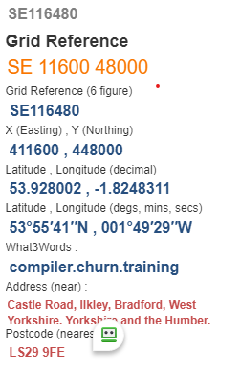
- Follow river path to cross Packhorse Bridge @ SE 113481 take river path on left.
- Cross road, turn left and up road to enter Owler Park Woods via a stile on left. SE 105488
- Follow path thro' wood, over back and stiles to arrive at Low Austerby, straight on keeping wall on left, right at road to reach Nessfield @ SE 095495
- Turn right uphill, turning left to village green, follow road on right to pass The Manor House @ SE 094496

- Follow lane uphill pass-through gate on left and follow rough track uphill passing F/P signs on left to reach Greenlane. (Lunch?)

- Continue forward thro' gates to reach Moorcroft farm building @ SE 100507

- Straight forward over boggy area to cross Langbar Road @ SE 1002510
- Follow path uphill to join path, turn right on moorland rack over Longridge to reach Old Milestone Post @ SE 108515

- Go straight forward at F/P junction to Foldshaw Ridge and shooting butts @ SE 112517
- Ahead to stone wall and turn right, follow rough track to OLD Milestone Post on left @ 114506 (near wall)
- Turn left thro' gate on reaching Hill Top Farm @ SE 123498, turn tight on road.
- Down road thro' Middleton Village, Pass red telephone box @ SE 124492, clock on right.
- Enter woods on left to pass Swimming baths, cross road to reach river, turn right to bridge and finish

