Title: Little Hare Head

- Nineish Mile Circular
- Start Point Bolton Bridge
- Grid Reference SE071530
- Map Explorer OL2 s Dales Southern & Western

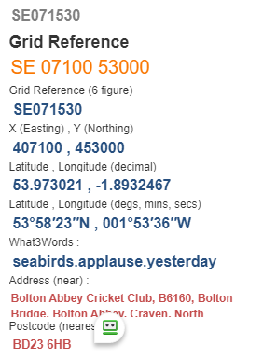

- Cross A59 and go uphill to Hawpike Farm @ SE 063525, go ahead to gate follow wall uphill to stile.
- Turn half-left downhill to meet path coming from right, go ahead and Cross stream and follow wall on your left, to pass through left gate @ SE 055526.
- Follow path half left downhill to cross small bridge nr. Haysholme, go Uphill to join track to Draughton @ SE 039525 turn left downhill to cross A59 @ SE044533
- Uphill to Halton East and follow Moor Lane Track to reach cattle grid at top road @SE038555.
- Turn right through gate and follow path to Little Hare Head @ SE054554 Continue downhill go through gate and turn half-left to enter woods @ SE068549 through to cross road into Bolton Abbey grounds and follow river path back to Finish.
