How to set up an Event / Walk in Meetup

- Firstly, I set you up as an organiser or assistant organiser.
- You then go to: https://www.meetup.com/wayfarers-mid-week-walking-group/
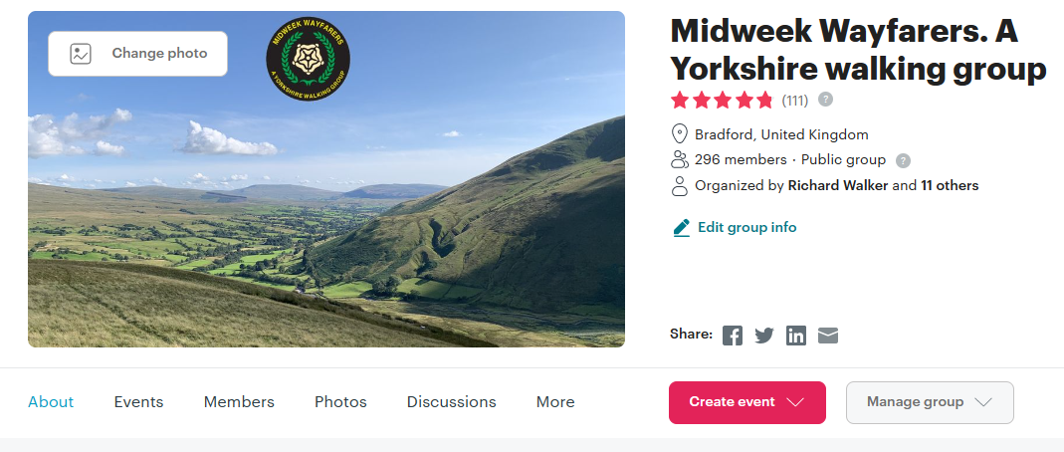
- Click on the Events button second from the left at the bottom.

- Click on Past
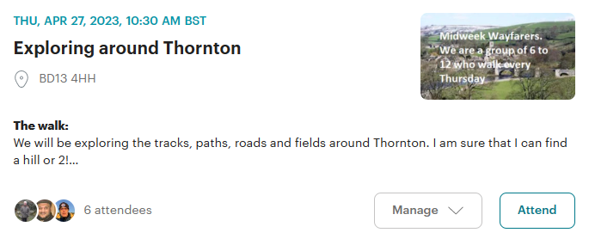
- On the example above you then click on ‘Manage’
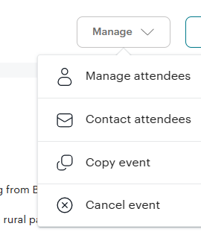
- On the ‘drop-down’ box click on ‘Copy event’
- Change the details from what you see to what you want the new Event / Walk to be.
- You can leave the picture or change it for one you want from on your PC.
- Most of the information can be gathered from the walk’s schedules on the web site e.g. https://www.seniorwayfarers.org.uk/thursday8to10.html or on Google Sheets https://docs.google.com/spreadsheets/d/10wUH1ozo-Bcdac1R8Kegas5i6Lv0E1_KQihHKLyCX_k/edit#gid=115362351
- Most of the information can be retained from week to week as it’s the same. Just alter it for the new walk. The rest can be ‘copied, and ‘pasted’.
- Update the What3Words link if you can.
- Don’t forget to alter the Post Code section and the How to find us section.
- Then ‘Preview’ it, then ‘Publish’ it at the bottom right-hand corner.

- Once published it should come up with an Announcement box to tell everyone about it.

