Title Heptonstall & Pennine Way

- Eight Mile Circular
- Start point: Hebden Bridge Rail Station
- Grid reference: SD995268
- Map Explorer: South Pennine OL 21

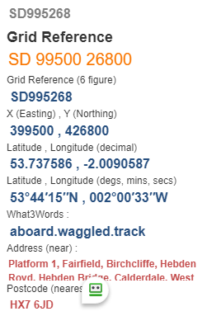
- Exit station and cross Park, over canal bridge and follow tow path, leave canal at bridge to cross A646, turn left 100yds and enter alley to ascend steps SD989271
- Up to road turn right 100 yds SD990272
- Turn left on track up hill for approx. 3/4 mile, after passing under overhead cable turn right SE986277
- Enter alley to reach working men's club SD988277
- Turn left to church, pass on left to reach square overlooking Churches SE987280
- Exit square left, up the road to pass school, take F/P of Left SD984282
- Veer half right to stile, forward past house cross lane, straight over drive SD980284
- Ahead to pass seat, continue to drop over stiles to wood edge SD975283
- Descend to Colden Water and cross dapper bridge SD968282
- Climb half left to steps and over track up hill on Pennine Way and descend to cross road SD968282
- Down track and over stile, continue forward to turn left on reaching track SE970269
- Straight ahead for approx. 3/4 mile. Before reaching Green House note a house on your right, go down side of house to pass through a gate, good views overlooking Hebden Bridge SD979273
- Descend winding path to turn left at path junction, pass houses turn left at road junction, rail line on your right SE979268
- Cross road at bottom passing pub to reach canal, SD983273
- Follow canal to park and rail station FINISH

