Title Height Laithe & Coniston

- 10 - ish mile circular
- Start Point Grassington Car Park
- Grid Reference SE002637
- Map Explorer Yorks Dales South

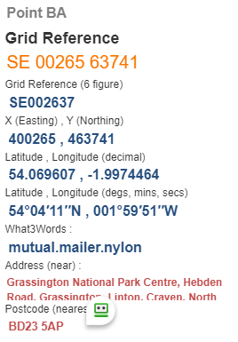

- From car park take F/P to cross Linton Falls Bridge, turn right at road junction to school turn left to pass playground, cross old rail line to reach road, turn right 200yds; then left down lane to cross B6265 @ SE9906637

- Pass pub on the F/P to the right and go over two wall stiles close together, turn half left to cross filed and go over wall stile; keeping the wall on your right go forward to cross another wall still forward to the next wall stile, then half right to enter Skirethorne Lane. Turn left and go through the village. Turn right on Wood Lane @ SE 973638

- Up Wood Lane to turn left to Wood Nook and pass thro' camp site, cross stile and stream and continue uphill, pass thro' wall stile to go past old building, Height House @ SE958645
- Forward uphill pass thro' gate, use the permissive path straight ahead, ignore F/P sign going downhill to your right. Turn right to reach Height Laithe (barn) good spot for Lunch. Forward to cross Malham Moor Lane @ SE96|0650.
- Continue over Malham Moor to turn right down Mastiles Lane, take F/P on right near Cool Scar and follow stream to reach the B6160 turn left 50yds then road right to cross river to Coniston @ SE981674.
- From "Square" of follow Grassington road and take F/P on left rising to follow contour of hill, cross wall stile on your right, at top of rise take stile on your left to keep grass wood over to your right join, the Dales Way path thro' to Grassington. Follow Chapel Street to Main Street Square and then Hebden Road to Finish.
