Title Hebden and Grass Wood
- 9 - ish Mile Circular
- Start Point Hebden nr Grassington
- Grid Reference SE026632
- Map Yorkshire dales South OL 2

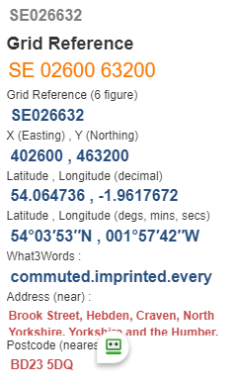

- Cross B6265 turn left 50 yds take Grassington F/P (not Tinkers Lane) Follow path past old hospital SE015635 (now new houses) to enter Grassington via HIGH LANE.

- Straight ahead on Chapel Street to take F/P on right Bank Lane after 10 yds bear left and enter enclosed lane. Ignore F/P on left continue to gate and enter open grassland area SE000651. Up slope to join the DALES WAY. Go left at 2nd path past LEA GREEN and left again to stile in wall SE993661 and bear left uphill to enter BASTOW WOOD and nature reserve.
- Follow path to reach a finger post SE989656 turn right and follow path downhill to Grass Wood Lane SE 981657 turn left on road OR take path on left exiting BEFORE wood.

- Take F/P on right to descend to River Wharfe and follow river path to cross B6265 near Grassington bridge, continue by river to LINTON falls SE002633. Keep on left of river and enter lane via wall stile with gate turn right past fish farm and houses, go through gate to enter large field near steppingstones SE008631.

- Follow DALES WAY by the River Wharfe until you reach the suspension bridge. TURN LEFT to road turn right over small stream bridge; then LEFT to pass through house gardens F/P SE029624.

- Uphill to pass fish farm on left, over stile up hill to HEBDEN and Finish!

- ALTERNATIVELY, @ SE008631 turn LEFT uphill and RIGHT at top, stiles galore!!

