Title Hebden and Blea Beck

- Eight Mile circular
- Start Point: Hebden near Grassington
- Grid Reference SE026632
- Map Explorer York's Dales South

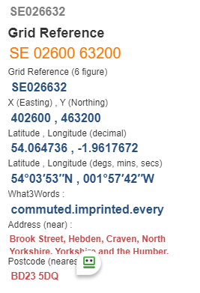

- Cross B6265 after 20yds turn right over Hebden Beck turn left past cottages, go thro’ gate alongside beck to your left. Path rises above beck, angle rift to arrive in corner. Over stone stile with wall on left to next field. Follow wall on right uphill with Hebden Gill Crag to the left and pass to right of ruined building.
- Up steep zig-zag path to wall end, follow left side of wall to reach open moor (finger post) go past house, over drive and stile (fingerpost), half left to vehicle track to cattle grid nr Scar Top House. Pass down right of wall to access land notice.
- Follow wall thro’ gate pass Mossy Moor Reservoir. Pass stone gate and stone stile to enter Backstone Edge Lane turn left onto walled track @ SE034642
- Continue on lane, when wall turns right continue ahead to cross brow towards Blea Gill, go thro' gate onto open moor. Reach Beck and follow left bank. Forward to track near mine reservoir @ SE041668.
- Go forward to old mine workings and chimney go down Dukes new Road and left thro' disused shafts to reach Hebden Gill Beck @ SE025658 .
- Follow the beck past Hole Bottom to cross B6265 and finish.

