Title Hebden and Bare House

- Ninety Mile circular
- Start Point Hebden nr Grassington
- Grid Reference SE026632
- Map Explorer York Dales South

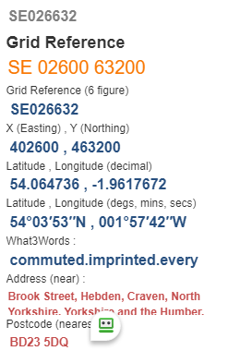

- From toilets cross B6265 and follow lane to cross Hebden Beck at Hole Bottom @ SE 023642 @

- Follow Hebden Beck until 500yds after ford, go uphill to pass thro' gate @ SE 024659

- Ahead to pas thro' old mine working area, to reach road at Yarnbury turn right for 50 yds then left onto F/P @ SE016661.
- Enter green lane follow to exit lane via a gate, keep forward until buildings on your left, go thro' gate on left to reach Bare House @ SE002644.
- Pass round house via small gate and keeping on the same line descend thro' fields and wall stiles to enter Grassington @ SE002644

- Follow road to top of Main Street ROUTE A follows High lane and thro’ OId Hospital grounds to enter Hebden near the Pub and finish ...
- ROUTE B from farm on entering Grassington turn right down road thro' houses and ginnels to reach river near road bridge @ SE999638.
- Follow River path (Dales Way) to near suspension bridge turn left @SE 025624.
- Forward to road right then left over small bridge turn thro' Mill Bridge house and follow F/P to pass fish farm, uphill, pass old school to Finish

