Title Hebden Linton Round

- Eight Mile circular
- Start Point Hebden nr Grassington
- Grid Reference SE026632
- Map Explorer York Dales South

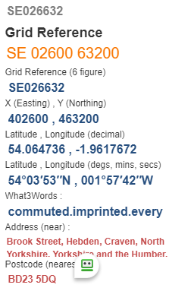

- Cross B6265 pass pub, take 2nd F/P on right, follow path to Grassington, pass thro' small wood and pass large houses on your right, keep ahead to enter Grassington via High Lane @ SE004642
- Turn downhill to reach information centre & car park, use F/P to cross river bridge turn left to pass toilets, take F/P on right then left fork over slope and narrow stile to cross road, go thro’ gate nearly opposite. SE007626.
- Uphill 40yds take wall stile on right, pass old barn on right, keep on to enter Linton for lunch by old footbridge SE 991627
- Retrace steps to turn right towards Brow Plantation SE 999622
- Keep ahead to turn left up track and join minor road turn right and follow road to Far Langerton SE997612
- Go thro' gate on left and follow F/P towards Elbolton Hill and enter Thorpe Village @SE026623
- Take road to your right to cross B6160, thro' gate opposite and descend too swing bridge SE026623
- Forward to road left then right over small bridge turn thro' Mill Bridge house and follow F/P to pass fish farm, uphill pass old school to finish.
