Title: Golden Acre

- Nineish Mile Circular
- Start Point Golden Acre Car Park
- Grid Reference SE267418
- Map Explorer 297

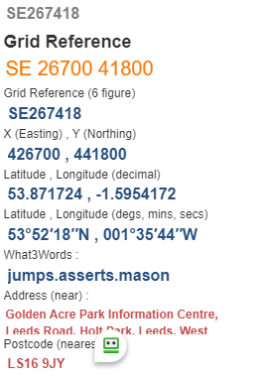
- Exit car park follow A660 for 200yds towards Leeds, take F/P on passing large pond on your right, exit wood to cross Golf Course and pass in front of club house, ahead road @ SE 253407.
- Forward for 500yds turn left after last house turn right onto F/P to pass Crag House Farm. follow field edges to turn right near rail air shafts SE 243418
- Keep forward to crossroad, thro' gorse bushes to cross the road to Bramhope turn right near telephone box, pass another air shaft and finally come out onto road near Post office @ SE 251433.
- Turn left to take F/P right after 50yds descend thro' houses to cross A660 keep right about 150yds then take F/P on left to descend thro' houses (tricky) to reach Cresceld Lane @ SE 256435 turn right up lane to go forward on F/P at sharp bend. Path passes quarry on left, enter road and go right until Bank Top turn left to pass thro' horse riding farm SE 271434.
- Follow Bank Top Lane just after Bank Side Farm make a right through gate go uphill to go left over stile near Bowshaws Ash area, follow path to turn Right near Brookland Farm @ SE 287428, at next gate make half right to pass Lineham Farm now a retreat for underprivileged children, follow lane on left to turn left again onto Black Hill Lane @ SE 278424. Turn right thro’ woods after 400yds and over stile onto King Lane turn right to junction of roads. @ SE 276417
- Go ahead down track to enter Golden Acre Park, there are plant trail and toilet facilities and a tea shop here if required. Bear left on path to pass UNDER the A660 Otley Road to car park and finish.

