Title Burnsall and Grimwith

- Eight Mile circular
- Start Point Burnsall
- Grid Reference SE032611
- Map Explorer York Dales South

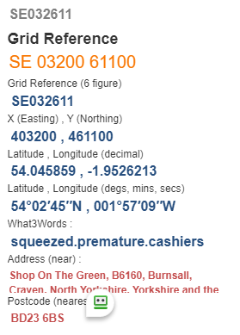

- From car park cross bridge, take stile on left and descend steps follow path by river return uphill (steep) to go thro’ gate stile and cross road thro' another stile, continue climbing and head for stile in righthand corner; follow ahead to enter road turn left road to reach Riakes Farm @ SE040617

- Go thro’ gate and follow F/P uphill keep to wall side, keep alert to cross wall stile on right, keep wall on your left to cross beck and pass by a stone barn, forward to pass Turf Gate House to turn left onto the B6265 @ SE 048631
- Keep ahead for about 600yds then right up Hartlington Moor Lane to turn right and pass stone barn @ SE 051647
- Follow F& to cross the Grimwith Reservoir Embankment, follow road left to car Park and toilet area @ SE06240
- Head south to pass cottages on your right and follow track to cross the B6265 again @ SE060630
- Take track opposite, ahead to reach minor road, after 200yds (approx.) turn right onto track @ SE 063620.
- Keep ahead to pass near some farm buildings and descend Kail Lane to cross road before reaching Woodhouse Farm @ SE040606 turn right to follow river F&P to Burnsall Bridge and finish.
