Title Bramhope Surprise

- Eightish Mile Circular
- Start Point Car Park nr pub
- Grid Reference SE248433
- Map Explorer 297

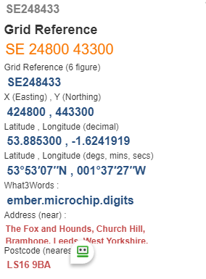

- Head toward A658, take F/P on right after last house. Follow path overlooking valley to cross (with care!) A658 @ SE 235437.
- Ahead on F/P to enter wood take path to the right either take path thro' trees or descend to pass Caley Crags. Both paths can bring you to cross East Chevin road @ SE 216444
- Take track to reach Surprise View to enjoy vista's over Wharfedale. Retrace steps 500yds approx. take path on right and half left to pass thro' gorse bushes to road @ SE 209440.
- Turn left on road approx. 440yds then take track on right thro' trees, over fields to go over stile on left to reach road @ SE 219430
- Follow road left until bend, with care cross to pass thro' Home Farm and ahead to cross A658 (fast traffic) @ SE226428.
- Over wall stile, follow path ahead ignore stile on right follow field edge to pas thro' buildings and cross Otley Old Road to reach bridge over beck up hill and reach road @ SE 236428.
- Go left 50yds then take stile on right, and follow fields and stiles to reach road, turn right to Finish.

