Title Ben?Guy Rail Walk

- Eight Mile Linear
- Start Point Ben Rhydding Rail Station
- Grid Reference SE135477
- Map Explorer 297

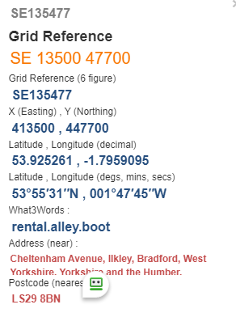

- Exit right out of station, take road on left with stone pillar. Uphill to take road on right to pass thro' special school buildings @ SE142467.
- Forward up lane to take F/P on left thro' iron kissing gate, down over beck bridge to pass to left of house. Follow path to enter lane, turn right and pass farm area @ SE146460.

- Road bends left, take F/P thro' gate and follow downhill passing Rushy Beck tree area to your left to reach Moor Lane, go left towards Burley in Wharfedale rail station @ SE 163458.
- Take track on right Before station to go over stile on left where track turns right over field and under rail bridge, "U" turn up to embankment, Follow in line of railway thro' fields to pass under rail bridge on right then follow railway to reach Menston Rail station @ SE175440.
- Cross station footbridge and turn right on road keep forward to cross A6018 near roundabout, take F/P on left to turn right near houses then forward to cross Buckle Lane. Keep ahead to pass Intake Farm @ SE185434. Left up road.
- Cross the Chevin End Road, turn right after 250yds to pass small farm to your right near Kelcliffe. Follow path half right go thro' stile in corner, go left overlooking works on right below you. Continue forward past houses to reach main road turn right towards finish.

