Title Barden Bridge & River

- 8 - ish Mile Circular
- Start Point Barden Bridge
- Grid Reference SE052574
- Map Explorer OL 2

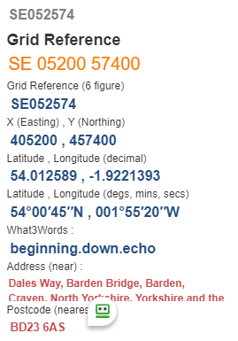

- Park near bridge, cross to west bank and go downstream uphill on the right to pass Strid Cottage & parking area turn right studs on B 6160 @ SE057567
- Over wall stile uphill 300yds turn right and follow wall on your right about 350yds turn half left near wall (It may be possible to cross road and add a "U" loop to join path near cattle grid then ahead to rejoin original route) follow path uphill turn left upon reaching track to Middle Hare Head about 1/4 mile forward @ SE049563
- Ahead on F/P and descend to pass thro’ gate, TURN half Left towards forest, enter wood via gate @ SE067549
- Follow winding path downhill, passing pond on your right to reach Bolton Abbey pass thro' grounds to cross river bridge @ SE075542
- You are now on The Dales Way F/P, follow the river upstream to the finish.

