Title Almscliffe Crag

- Eight-mile circular
- Start Point Pool Bridge
- Grid Reference SE247456
- Map explorer 297

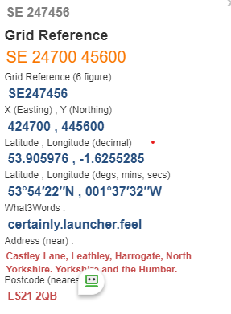
The what3words locations are taken from Grid Refences provided by memebers. Some of the Grid Refences are approximate so subsequently so are the what3words. Always carry an OS map for accurate locations. Should anyone doing this walk wish to provide more accurate grid refences or what3words combinations the route will be amended accordingly.

- Start: https://what3words.com/certainly.launcher.feel
- Turn right onto river F/P, follow path to road to pass Castley, take stile on right SE269459 https://what3words.com/tour.potential.organic
- Uphill to pass under rail bridge, left to top, Westcoe Hill Lane @ SE277464 https://what3words.com/driving.lofts.bolsters
Turn left, at road bend go through gate ahead follow F/P down to A658 cross and turn right 200 yds. Take wall stile on left.

- Climb uphill go over stile forward to pass between houses and cross road to enter F/P winds thro' houses to Cross road, downhill to cross beck, uphill to skirt Holly Hall @SE274482 https://what3words.com/stay.limes.outs
- Left uphill to road, pass over stile on right to reach Almscliffe Crag. Down to road, go left and take lane on right to reach Lower Banks Farm @ SE262480 https://what3words.com/shortcuts.bells.crispy

- Take path on right Before house, follow path around three sides of field to pass thro' gate and descend Round Hill to reach Bogridge Farm, thro’ gate on right then left to pass house, turn left thro’ gate at bottom of slope.

- Forward thro' gates to take path on right thro' Riffa Woods to cross beck @ SE 252471 https://what3words.com/also.footpath.risen

- Half left across field to join track, follow right towards Leathley Hall, @ junction of F/P crossroads, @ SE240467 https://what3words.com/roadways.booms.choice turn left thro' gate to cross fields before Crossing the B6161. Half left to Pool Bridge and Finish.

