Wharfedale Wander
- 8 Mile Circular
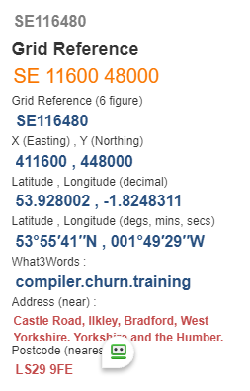
- Map: OS Explorer 297
- Start point:

- Follow the river path to join Dalesway Path, turn left at the Hollins@ SE098483 - What3words: issues.flagpole.truffles to cross the A65
- Over fields to pass thro’ Netherwood Farm@ SE090478 –
What3words: gasping.steepest.tunnel
- Uphill towards Cragg House Farm @ SE084476 -
What3words: blushes.wimp.mourner
- Join track/road turn right towards Addingham Moorside @ SE076478 - What3words: running.staples.functions
- Turn right downhill to reach Small Banks @ SE078487 –
What3words: comment.grandson.technical
- Go across road and continue forward to cross A65 @ SE082493 –
What3words: comment.grandson.technical
- Foreword to cricket field turn right along B6160 bear left towards Suspension Bridge over river @ SE083499 -
What3words: autumn.again.bonus
- Pass West Hall turn right thro’ fields to cross stream in wood continue uphill towards Height Lathe
- Follow track right to Nessfield @SE096496 –
What3words: autumn.again.bonus
- Turn Left on road approx. 200 yds then thro’ gate on left.
- Head to pass Low Austerby @ SE100490 -
What3words: autumn.again.bonus then thro’ Owler Park Woods
- Turn downhill at road to river path and Packhorse Bridge turn left to finish.

