Killer cows

On their walk in Netherton, Wakefield in September 2020, Michael and Teresa Holmes were yards from a stile, on a public footpath, with their two whippets as they crossed a field of cattle with calves, when at least 25 cattle ran towards the couple and trampled them.

Michael suffered 35 rib fractures and lacerations to his heart and was pronounced dead at the scene. Teresa was knocked unconscious and suffered spinal cord damage, spinal fractures and fractured ribs. She is now confined to a wheelchair for life and has had to give up work.

This was not an isolated case, in fact it was the third fatal cow trampling in the North in the space of a month and three other people had previously been chased by the same herd in Netherton. In the year 2020-21, nationally, 11 people were killed by cows, 5 of them members of the public. In the same year 31 people sustained non-fatal injuries.

Ruth Livingstone, a retired GP, launched a blog in 2017, Killer Cows, to publish her research and allow others to report their own incidents. In almost six years, she has collected 580 reports of cow attacks or near-misses on members of the public, most of which occurred on public footpaths. Only 2 per cent involved single bulls.

The received wisdom is that the vast majority of attacks on members of the public occur when cows with calves are threatened by dogs. But no dogs were present in more than half the incidents and calves were present in only about a fifth. “Cows are kept indoors during the winter, so in Spring, it all begins to kick off,” Livingstone says. “People are out walking and the cows are frisky because they’ve been locked up for so long.”

Male Limousin cattle, one of the most popular breeds in Britain, can weigh up to a tonne and Friesian cattle up to 775kg. Cows can run at an average speed of 17mph, but over short distances they can top out at 25mph — only slightly slower than Usain Bolt in his prime.
“Cows are heavy. That’s where the danger comes from,” says Andrew Marshall, an agricultural consultant. The herd mentality and fight or flight response are what leads to most of the injuries by accidental crushing, he adds. “Cattle are territorial and …they are always pushing the boundaries. They can learn that if they run up to humans, the humans will run out of their field. Then they can become more confident and more determined to remove what they perceive as a threat. This confidence is built up over time — it may take years — and the farmer wouldn’t necessarily know anything about it. People are often frightened if a herd comes towards them. If they’re leading with their noses ahead, they’re curious. But if their ears go up at ten to two that’s the classic threat posture.”

There are different reasons why cattle approach humans - curiosity, fear or the maternal need to protect their young. “Cattle, and dairy cows in particular, are amazing, intelligent and calm animals,” she says, “but all large animals come with their inherent dangers to humans.”

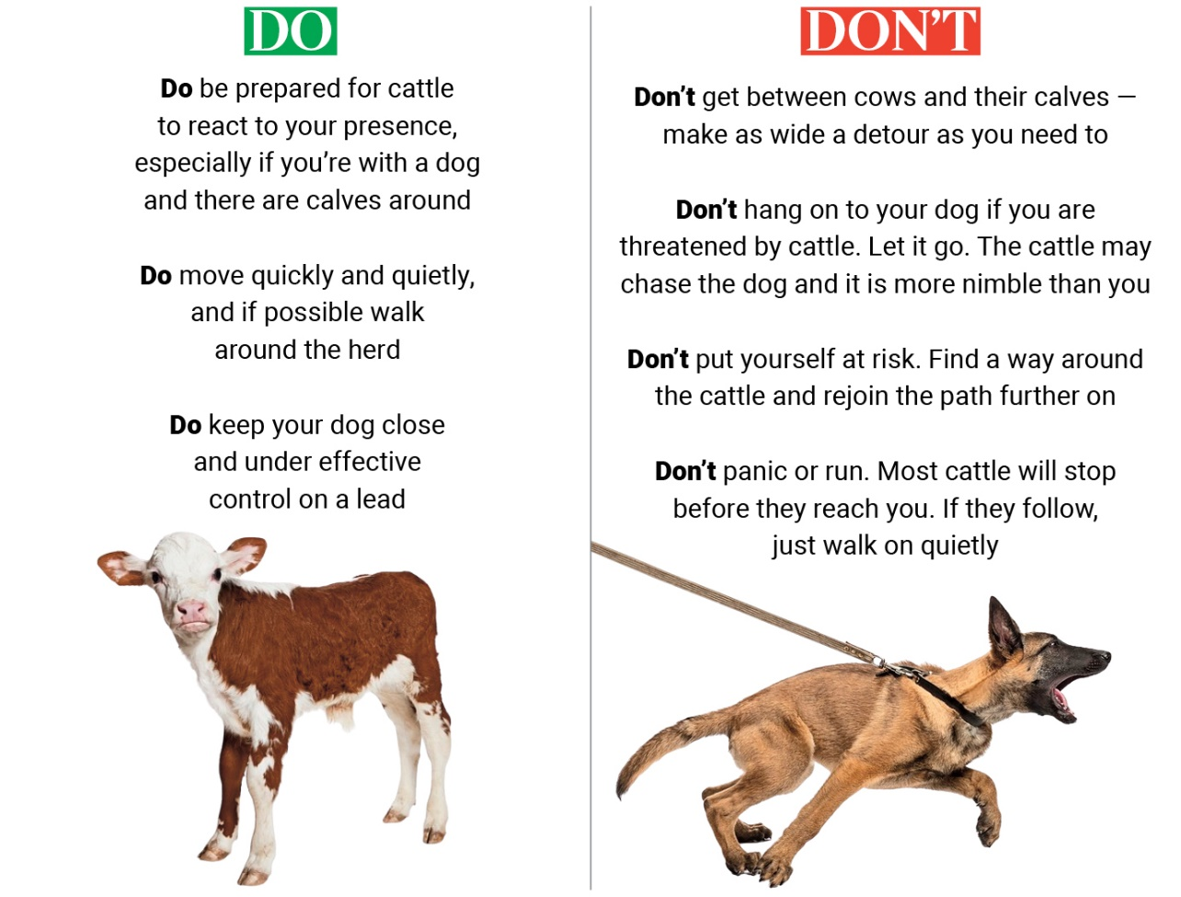
The Killer Cows group says European breeds such as the Limousin are more aggressive than native breeds, as are crossbreeds. They also claim that the advent of machine farming, including self-milking machines, has made cows more wary of human contact, but David Exwood, vice-president of the National Farmers’ Union (NFU), says there is no evidence that incidents are increasing, nor that machine farming or breed type are factors in cow attacks. “I would never tell anyone that one breed is safer than the other because all cattle can hurt you,” he says. “They are all unpredictable large animals [that] need to be treated with respect and awareness.”
.

