Title of Walk: John of Gaunt
Distance: Eight Miles - circular
Start point: Swinsty car park toilets
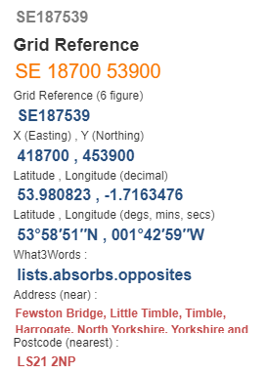
Map Explorer: 297
The what3words locations are taken from Grid Refences provided. Some of the Grid Refences are approximate so subsequently so are the what3words. Always carry an OS map for accurate locations. Should anyone doing this walk wish to provide more accurate what3words combinations the route will be amended accordingly.

- At car park entrance turn right to cross embankment, turn right down steps. Follow water edge path to pass thro’ picnic @ SE199536 What3words: https://what3words.com/clear.jousting.rope . Turn right over road bridge then take FP left at end of bridge.
- Up thro’ woods to cross the road at pub @ SE206537 https://what3words.com/totals.skid.lease . Pass thro’ pun grounds and take left path below Bank End Farm @ SE212542 https://what3words.com/adverbs.ranches.represent .
- Continue forward to cross bridge over Beaver Dyke @SE222546 https://what3words.com/brain.layers.rewriting .
- Uphill to John O Gaunts ruins then up slope to pass round East Manor Farm @ SE219544 https://what3words.com/vesting.refilled.unloading .
- Half left to stiles to reach Brown Bank Farm @ SE215537 https://what3words.com/pelt.cello.samplers .
- Go thro’ farmyard, thro’ gate and down steps, forward to stile then left to road.
- Turn right for approx. 300yds. Then left thro’ gate to reach Bland Hill @ SE207533 https://what3words.com/paces.fatter.humble .
- Down Hill to turn left at road and cross embankment then turn right. Then Either follow track to finish OR pass Swinsty Hall @ SE194534 https://what3words.com/retire.boom.confining then right thro’ woods to finish.

