Title Height Laithe & Grassington
- Eight Mile circular
- Start Point Grassington Car Park
- Grid Reference SE002637
- Map Explorer Yorks Dales South

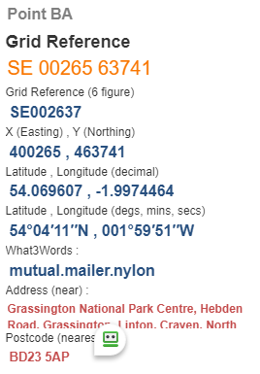
- From car park take F/P to cross Lipton Falls Bridge turn right over small Bridge, reach road and turn left to school, turn right to pass playground across old rail line to reach road, turn right 200yds; then left down lane to cross B6265 @ SE990637
- Pass pub on the F/P to the right and go over two wall stiles close together, turn half left to cross field and cross another wall stile, forward to the next wall stile then half go over wall stile, keeping the wall on your right go forward to right to enter Skirethorne Lane turn left and go throw the village. Turn right on Wood Lane in SE973638
- Up wood Lane to turn left to Wood Nook and pass thro' camp site, cross stile and stream and continue uphill, pass thro' wall stile to go past old building, Height House @ SE958645
- Forward uphill pass thro' gate, use the permissive path straight ahead ignore F/P sign for going downhill to your right. Turn right to reach Height Laithe (barn) good spot lunch. Retrace steps to go thro’ gate and cross High Moss moor, it can be very boggy to enter track between walls, ignore east path to your left, turn left to and stony track @ SE958628.

- Follow track over Threshfield Moor passing old mine workings to enter Moor Lane thro' gate follow downhill to cross B6265 left 25yds then thro' gate on your right towards Linton village. Cross old rail line to enter Linton with stream on your left, turn left at road to cross road bridge @SE 997628

- At fork in road, bear right to cross Burnsall road, turn left onto F/P after 50yds towards river, pass toilets and turn rift over river bridge uphill to Finish.

