Title of Walk: Dean Beck
Distance: Eight Miles - circular – anti clockwise
Start point:
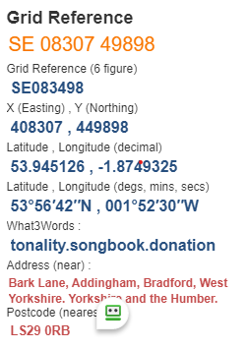
Map Explorer: 297
The what3words locations are taken from Grid Refences provided. Some of the Grid Refences are approximate so subsequently so are the what3words. Always carry an OS map for accurate locations. Should anyone doing this walk wish to provide more accurate what3words combinations the route will be amended accordingly.
- Cross river suspension bridge, pass West Hall r to road, go thro’ gate where road bends left. Uphill to pass thro’ gate on left and continue to reach Black Foss Farm@ SE093514 https://what3words.com/tech.rezoning.outer
- Pass thro’ farm to near left up road, pass up drive of Ferrand House@ SE090516 https://what3words.com/shocked.braved.corkscrew. Take stile on right, up steps and follow wall to Howber Hill Farm, go ahead to road @ 091522 https://what3words.com/adhesive.surely.dwarves
- Cross over road and take path towards Ling Chapel Farm. Before the farm go thro’ gate and reach Deerstones @ SE089530 https://what3words.com/shot.hires.vouch
- Follow the stream to Beamsley Village, turn right on road and meet A59, turn left to river bridge @ SE076518 https://what3words.com/banks.contour.shudders
- Use Dalesway path to reach Lobwood House, then trace river thro’ Caravan park to finish

