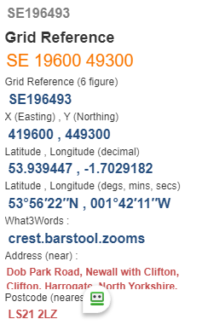
Dob Park and Askwith
- Start Point:

- Eight Mile Circular
- Map OS Explorer 297

- Go down track to reach Crag Farm @ SE205487.
What3words: momentous.joked.snappy, turn right thro’ gate uphill to pass thro’ gate at top. Half right across field go over stile in wall, ahead to stile in fence turn right and follow path to cross a stile and beck @ SE199483 - What3words: scan.skater.encroach

- Continue forward to cross stile and Newall Carr Road, follow the road to reach Clifton Village, bear right to pass thro’ house gate and stepover stile, go right to cross beck and stile near Lane Head Farm track @ SE189483 - What3words: they.firelight.varieties

- Keeping hedge on your left, ahead to go thro’ small copse, cross stream to pass thro’ Covey Hall Farm (scrap junk) head half left to go thro’ wall stile, ahead to go over stile and beck, continue forward to turn right at lane leading to Grassgarth Farm @ SE180485 -
What3words: familiar.masterpiece.heckler

- Just before the farm take stile on left, half left to cross stiles leaving farm and stream to reach Askwith Town Head, down road 50 yds go thro’ gate on right after Rose Cottage @ SE 171485 –
What3words: drooling.dads.cubes

- Go ahead to pass small lake on right (hidden by trees) to turn right in Hall Lane. Follow up lane passing Scale House Farm, to pass over cattle grid Whin House Farm to go thro’ Top Moorhouse Farm @ SE 166500 -What3words: react.guideline.puts Follow track forward to climb uphill to Weston Moor Road go right to crossroads downhill 200 yards then left over wall stile.

- Half right and follow track to pass wood on left and large area of rhododendrons to your far right. Ahead to pass the house to your left @ SE190491 - What3words: stadium.interests.fittingly

- Half right to go thro’ gate continue ahead to go thro’ Higher Carr Farm to reach road, uphill left to finish
