Arnside Holiday 2024

The holiday in Arnside commences on Saturday 28th September. It is for a week.
The charge is £405 and includes, bed, breakfast, evening meal and a packed lunch.
The last 2 years have been extremely successful. To book contact Verner Wheelock verner.wheelock@vwa.co.uk Please do not go direct to Parkside.
Parkside Guest House, 59 Redhills Road, Arnside, Via-Carnforth, LA5 0AU Telephone: 01524 761815
Email: office@parksideguesthouse.uk
www.greycourtholidays.co.uk

The Walks

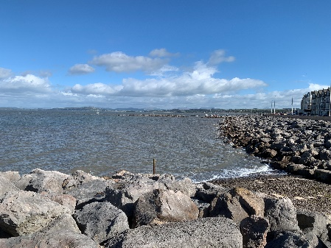
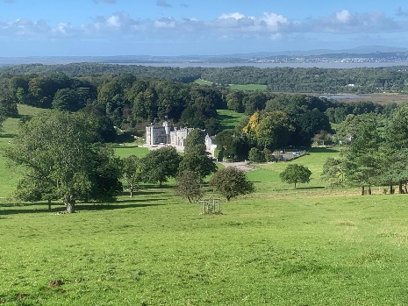

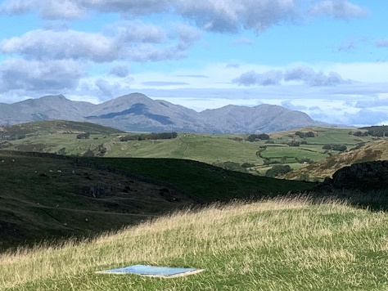

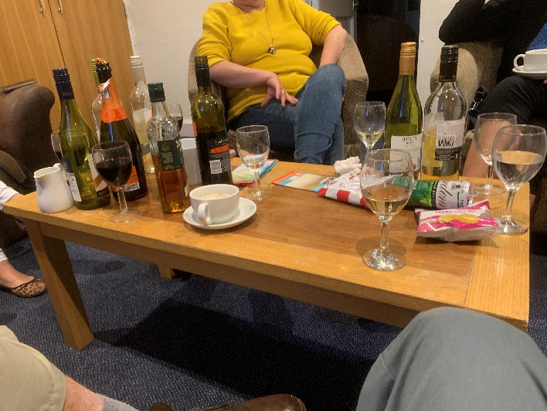
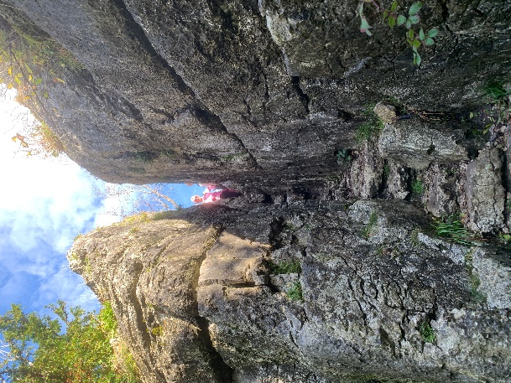
The relaxation!

